https://www.youtube.com/watch?v=CnXdddeZ4tQ
https://www.youtube.com/watch?v=CnXdddeZ4tQ

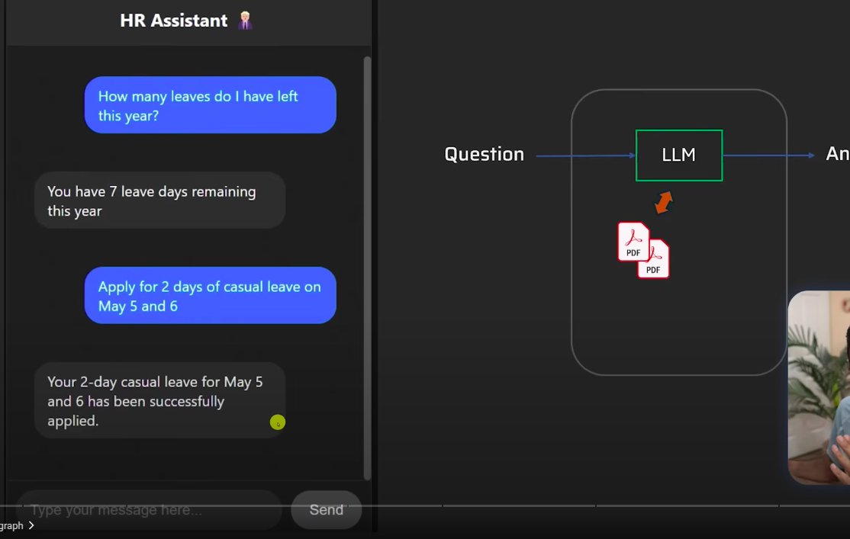







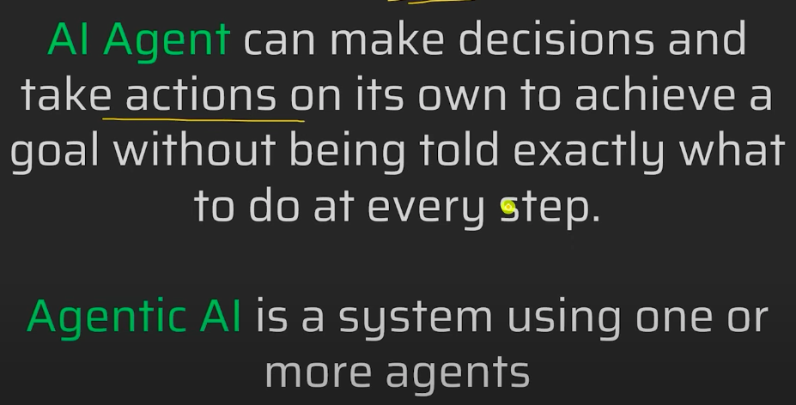

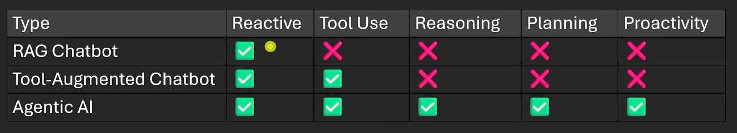



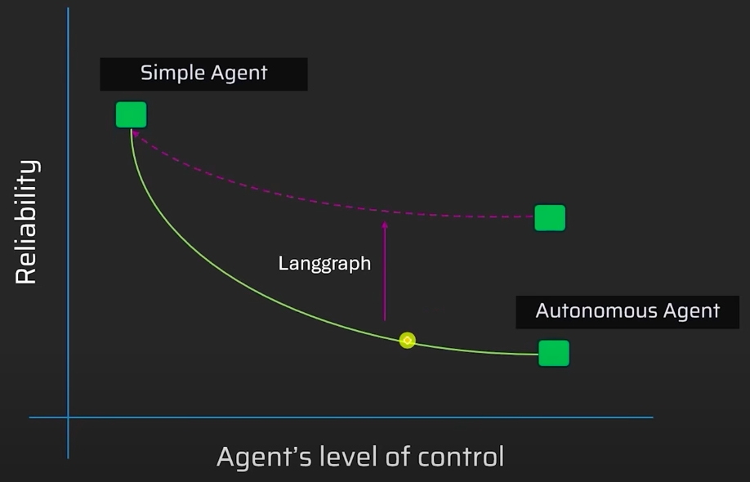

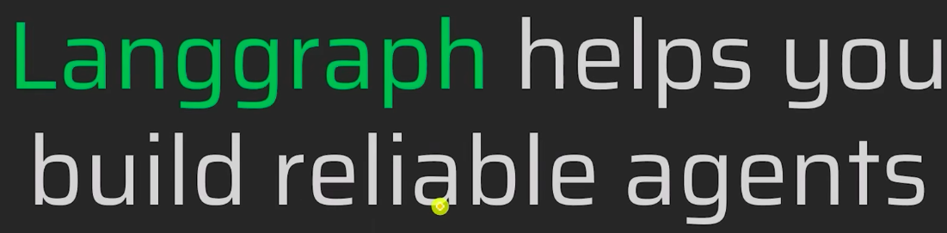

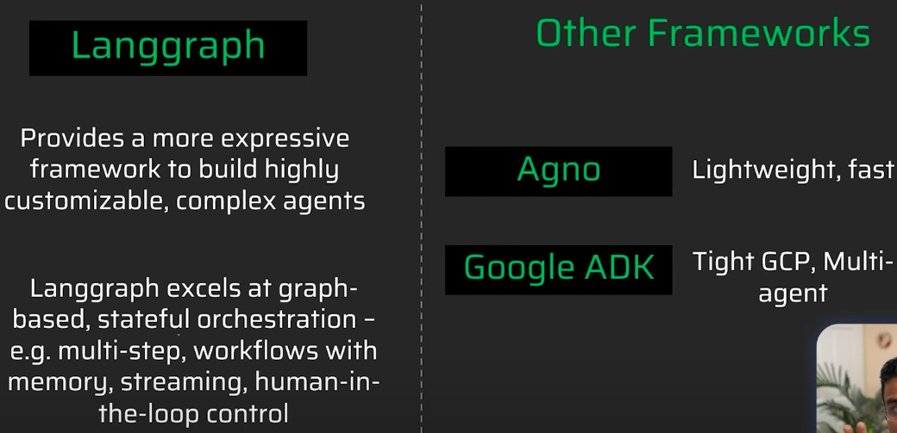

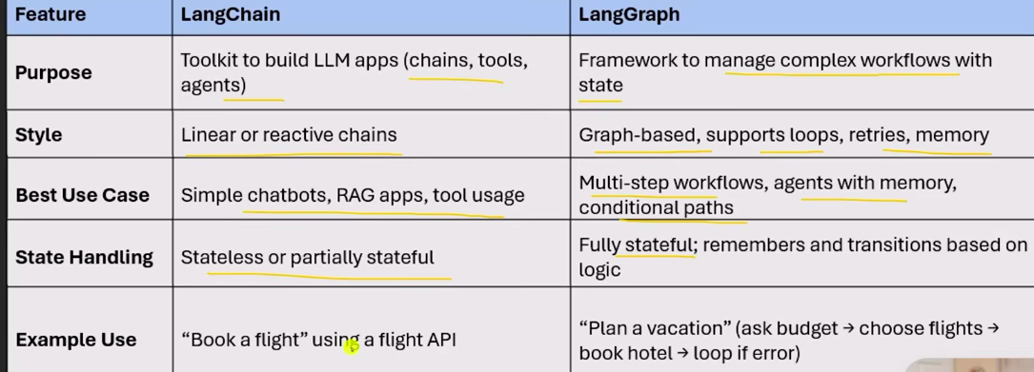

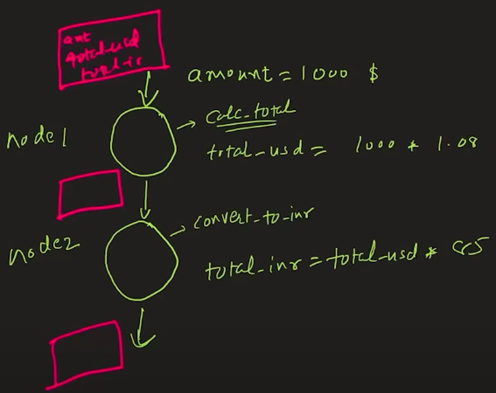

LangGraph = Sate , Node, Edges
State : parameter for function, output from a function
Node : Function name

minimal example of how LangGraph works:
- Define state
- Write nodes (functions)
- Connect nodes with edges
- Compile + invoke

